Name: Tran Khanh Tai
ID: ITITIU21300
Lab 6 Practice
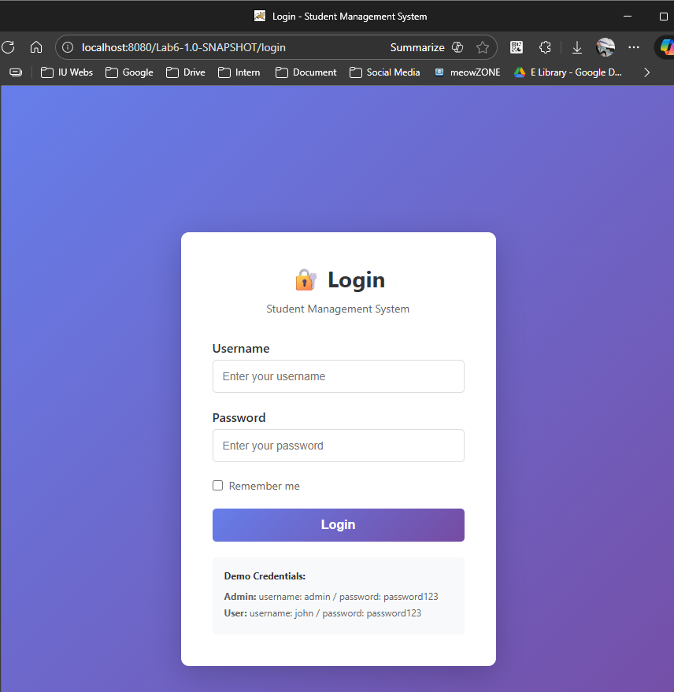
This is the login page when we try to access the web page.
Here we have 2 account to login to this web.

For admin account:
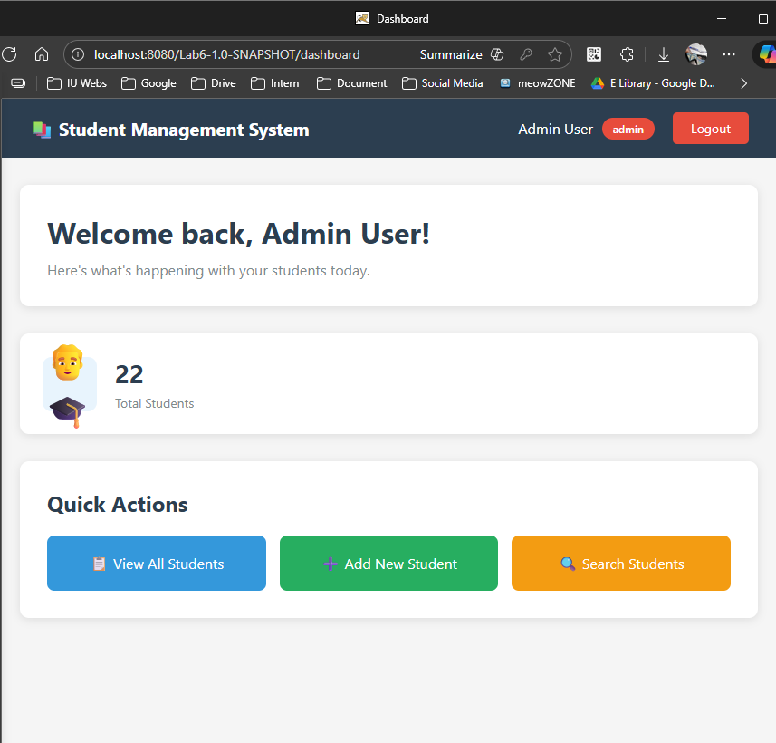
Here is the dashboard of admin:
+ Admin can view the list of students and the number of students in the list (here we have 22 students in the database)
+ Add student
+ Search students

List all students:
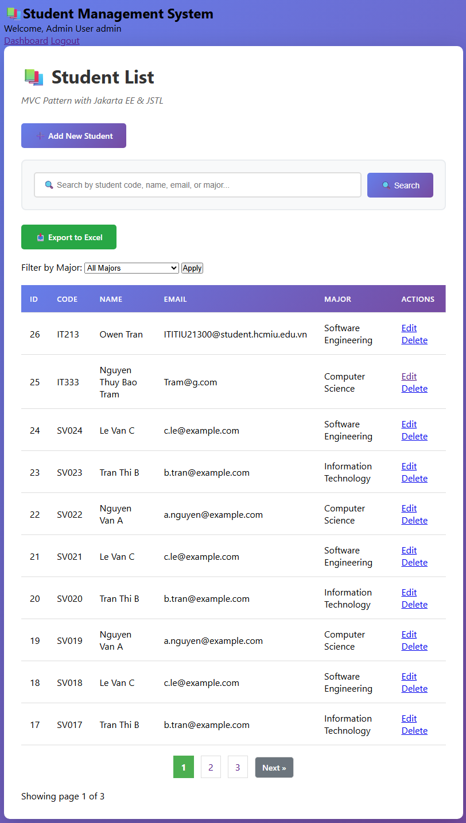
In the student list, admin can Edit or Delete the student information.
For User accessing:
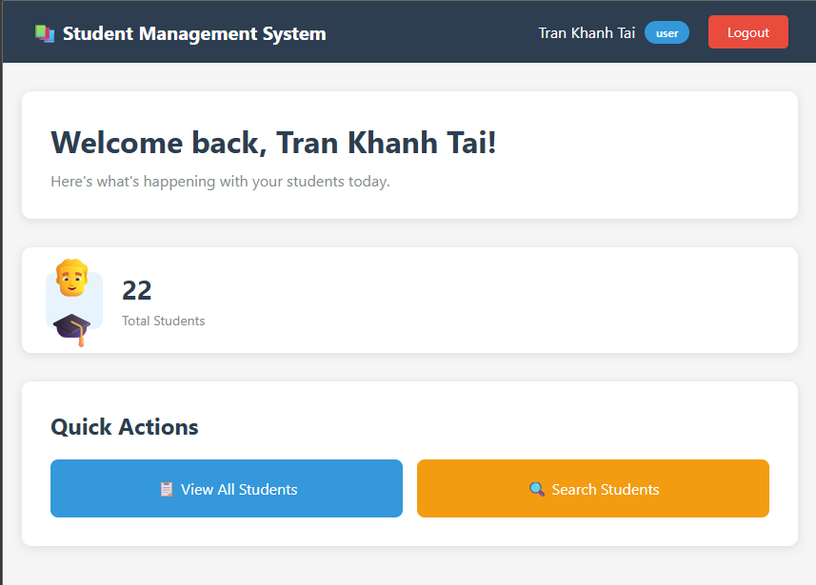
After login, we go to the dashboard page, but the User can’t Add new student like Admin, it just can view all students and search student.
And the User also can’t edit or delete the information of the student in the list like admin
It just can Search student by ID, Code, Name, or Email.
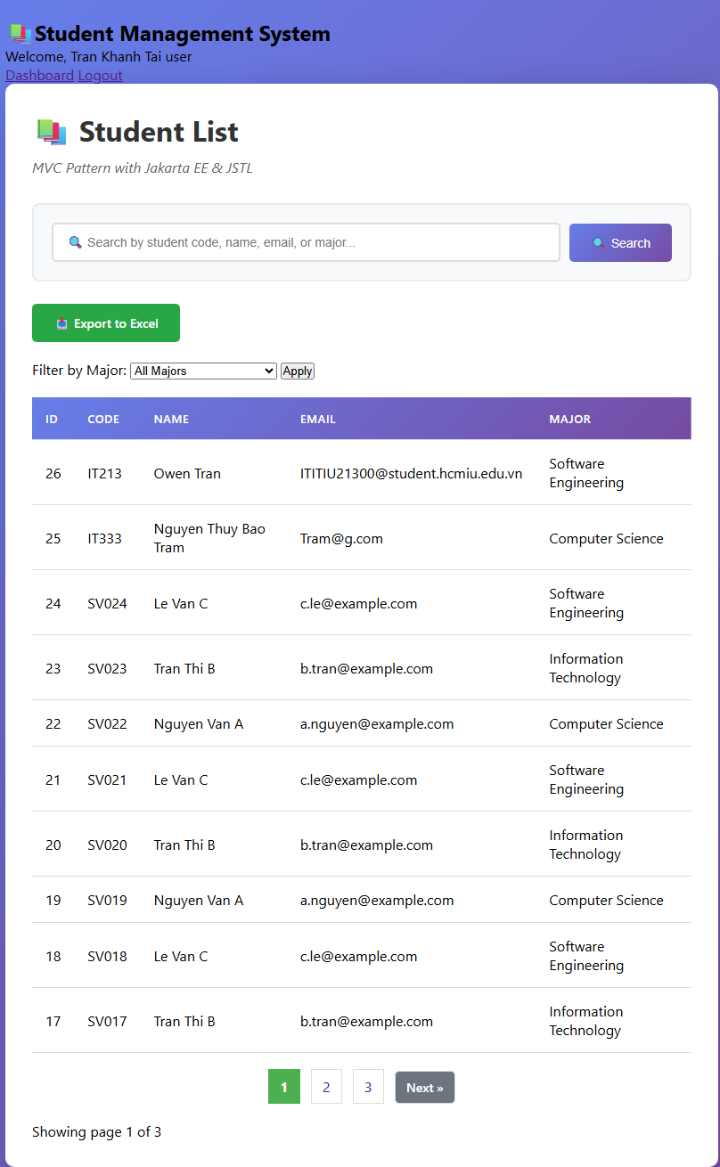
Test login flow
1. Access: http://localhost:8080/Lab6-1.0-SNAPSHOT/
→ Redirected to login (AuthFilter)
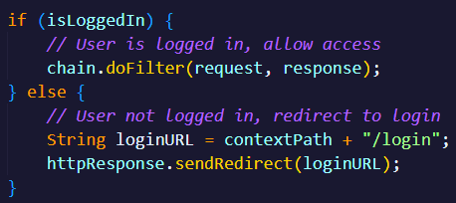
- When visit the root URL, AuthFilter checks if you're logged in
- Not logged in → redirected to login page
- Admin login creates a session with user info and redirects to dashboard
2. Login with: admin / password123
→ Creates session
→ Redirected to dashboard
- Admin users see full CRUD functionality (Add/Edit/Delete buttons)
- AdminFilter allows access to administrative actions
3. Click "View All Students"
→ Shows student list
→ Edit/Delete buttons visible (admin)
4. Logout
→ Session invalidated
→ Redirected to login
5. Login with: john / password123
→ Regular user view
→ No Edit/Delete buttons
6. Try to access: /student?action=new
→ AdminFilter blocks access
→ Error message displayed
- Regular users can view data but not modify it
- When trying to access admin-only URLs, AdminFilter blocks them
- Shows error message instead of allowing access
http://localhost:8080/Lab6-1.0-SNAPSHOT/student?action=list&error=Access%20denied.%20Admin%20privileges%20required.
Test URLs:
Public (no login required):
- /login
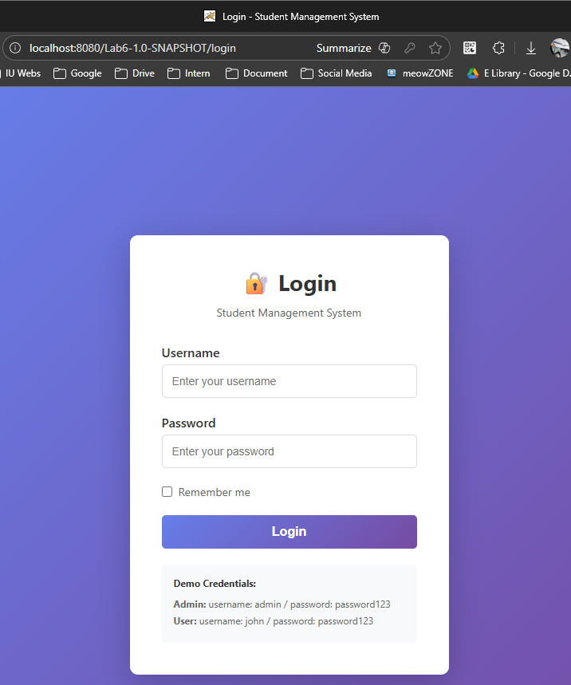
- /logout
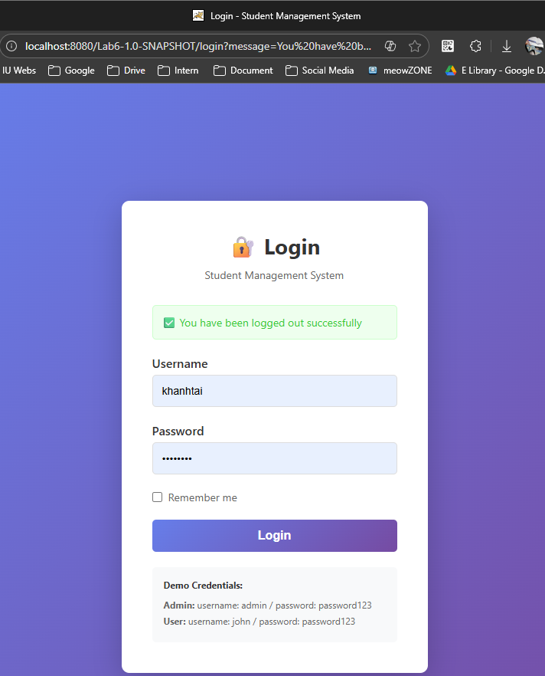

Protected (login required):
- /dashboard
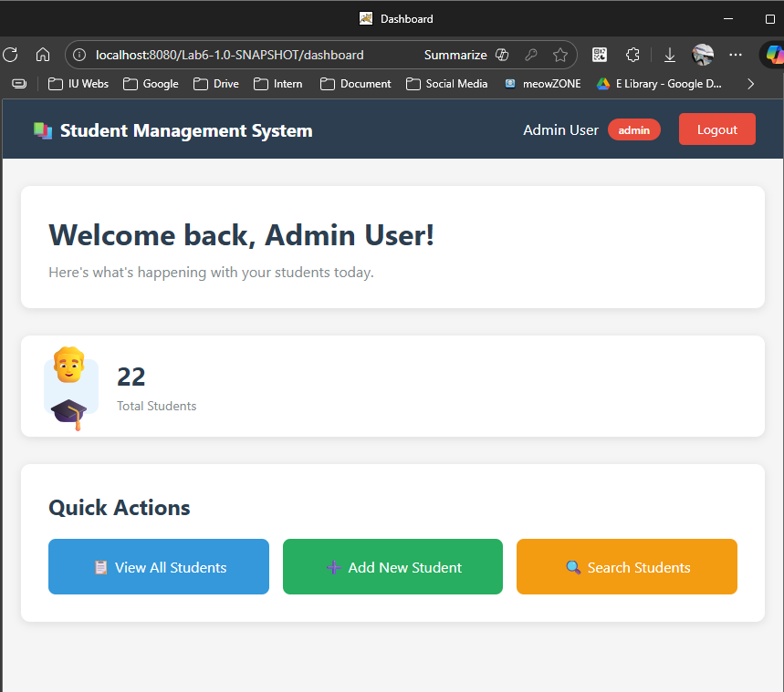

- /student?action=list
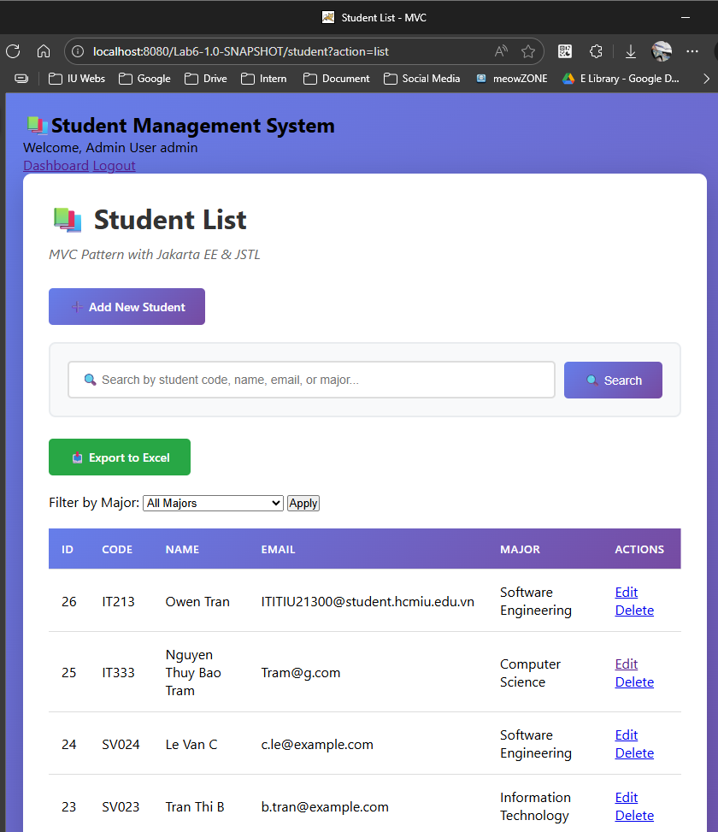

Admin only:
- /student?action=new
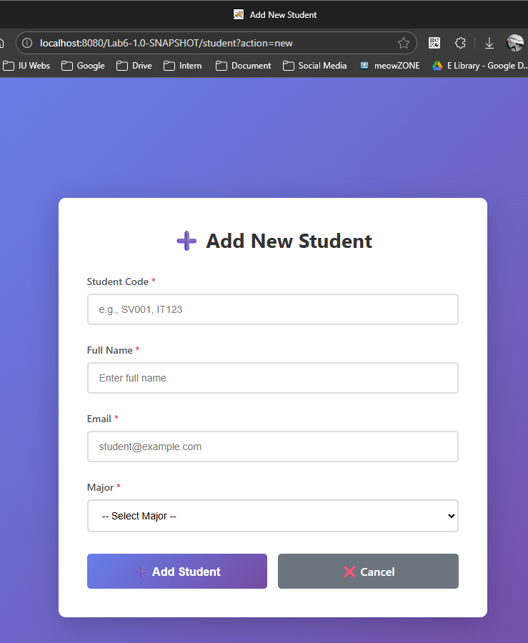
- /student?action=edit&id=1
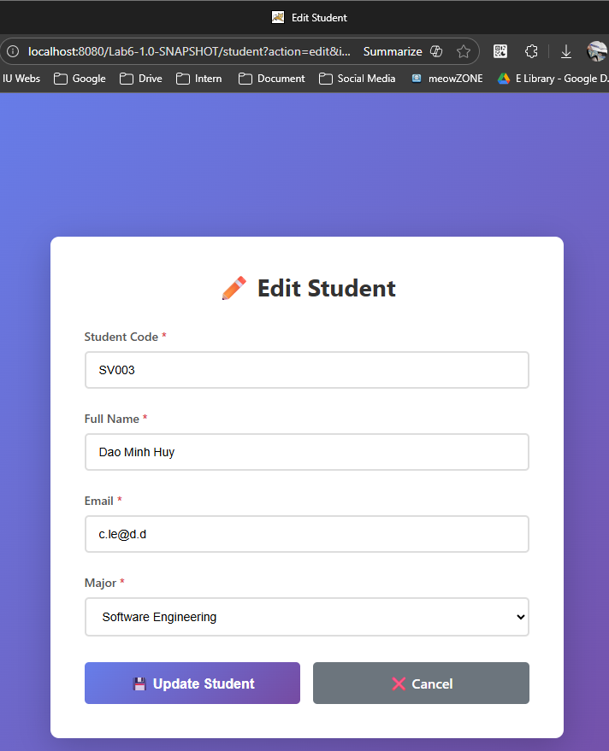

- /student?action=delete&id=1
It will delete the student with id = 1

